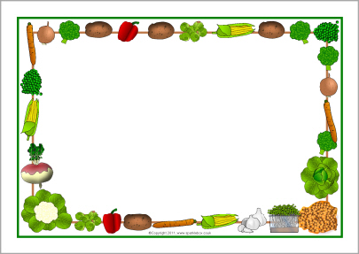

Week 1 |  | Monday | Tuesday | Wednesday | Thursday | Friday  (Short)
Protein  Option 1  Option 2 |  | Tuna  Vegetable patties | Vegetarian shepherd’s pie | Scrambled eggs  Vegetable patties | Quiche  Lentil hot pot | Sandwiches:  Tuna or egg  Mayonnaise
Vegetables |  | Hot green beans Courgettes in tomato sauce | Hot green beans Courgettes in tomato sauce | Hot green beans  Courgettes in tomato sauce | Hot green beans Courgettes in tomato sauce
Carbohyrdates  Option 1  Option 2 |  | Pasta | Sweet potato mash | Rice  Chips | Rice  Cous cous | Whole meal bread  White bread
Desert |  | Fresh fruit  Yoghurt | Fresh fruit  Yoghurt | Fresh fruit  Yoghurt | Fresh fruit  Yoghurt | Fresh fruit  Yoghurt
Gluten free |  | Pasta  Vegetable patties | Vegetable pie | Vegetable patties | Lentil hotpot  Rice | Gluten free bread for sandwiches
Daily option of bread
Salad Bar: | grated carrots, tomatoes, cucumber and mixed peppers
Fruit Salad: | apple, melon, raisins, pears and banana

Week 2 |  | Monday | Tuesday | Wednesday | Thursday | Friday  (Short)
Protein  Option 1  Option 2 |  | Bean stew  Scrambled eggs | Lasagne  Butter bean hotpot | Falafel  Humous | Chilli con carni  Butter bean casserole | Tuna or egg  Mayonnaise
Vegetables |  | Hot corn or beetroot | Hot corn or beetroot | Hot corn or beetroot | Hot corn or beetroot
Carbohyrdates  Option 1  Option 2 |  | Rice  Cous cous | Rice  Cous cous | Pita  Chips | Pasta | Whole meal bread  White bread
Desert |  | Fresh fruit  Yoghurt | Fresh fruit  Yoghurt | Fresh fruit  Yoghurt | Fresh fruit  Yoghurt | Fresh fruit  Yoghurt
Gluten free |  | Bean stew  Rice | Butter bean hotpot  Rice | Eggs  Chips | Butter bean casserole  Pasta | Gluten free bread for sandwiches
Daily option of bread
Salad Bar: | grated carrots, tomatoes, cucumber and mixed peppers
Fruit Salad: | apple, melon, raisins, pears and banana

Week 3 |  | Monday | Tuesday | Wednesday | Thursday | Friday  (Short)
Protein  Option 1  Option 2 |  | Lentil hot pot  Quiche | Lasagne  Chick pea hotpot | Veggi burger  humous | Tuna bake  Butter bean casserole | Sandwiches:  Tuna or egg  Mayonnaise
Vegetables |  | Peas or  carrots | Peas or  carrots | Peas or  carrots | Peas or  carrots
Carbohyrdates  Option 1  Option 2 |  | Cous cous  Rice | Pasta | Burger bun  Chips | Mashed potatoes | Whole meal bread  White bread
Desert |  | Fresh fruit  Yoghurt | Fresh fruit  Yoghurt | Fresh fruit  Yoghurt | Fresh fruit  Yoghurt | Fresh fruit  Yoghurt
Gluten free |  | Rice  Lentil hotpot | Pasta  Chick pea hot pot | Home made burger | Butter bean casserole | Gluten free bread for sandwiches
Daily option of bread
Salad Bar: | grated carrots, tomatoes, cucumber and mixed peppers
Fruit Salad: | apple, melon, raisins, pears and banana

