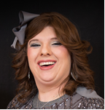
Nahva is a practising nurse at a GP surgery and has been for the past 12 years. She studied nursing in South Africa before coming to live in the UK
Nahva works for a number of local organisations as a volunteer mostly in her capacity as a nurse. She is currently a governor of Noam Primary school. As safeguarding is such an important feature in all aspects of her work it was fitting to elect Nahva as Kisharon School's governor with responsibility for safeguarding. Nahva has a special needs daughter which brings her role and passion together to have an outstanding school

