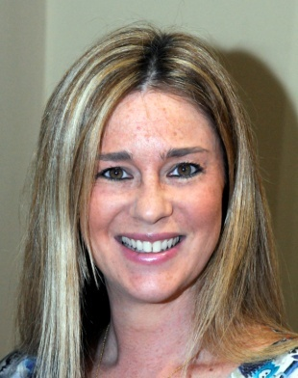
Emma Castleton has been Chair of Governors for 6 years, before that she was a parent Governor of the School. In the years she has been Chair, many changes have been made to the governance structure of the School, ensuring that it meets the requirements for both Ofsted and for the transition to Free School. These changes include building the skills needed for an effective governing body, ascribing named governors for specific roles and setting up 2 main committees which look at School Development and Finance and Premises. As well as working closely with the Head Teacher, she also works with the management and trustees of Kisharon Ltd., the current owners of Kisharon School in order to ensure a smooth hand over when Kisharon transitions to Free School.
Emma’s background is in International Media. She has worked for the Financial Times for 23 years, holding a number of management positions, she now works part-time to fit in with her family’s needs. She brings management, marketing and business experience to the Governing body as well as the experience of having a child with profound and multiple needs. She is married with 3 children aged 13, 9 and 8.

